Experiment No. 3

Aim: Implementation of all dimension table and fact table based on experimental case study.

Theory:
Our experimental case study topic is “Restaurant Management System”. Implementing dimension tables and fact tables on them, basically we are implementing the following,

The structured SQL schema presented here models a restaurant's data using the star schema approach, a popular design for data warehousing. The star schema involves a central fact table, in this case named Restaurant, and dimension tables such as Customers, Menu_Items, Payment_Methods, Time, Locations, and Employees. Each dimension table holds unique attributes, while the fact table contains measurable metrics.

The Customers table captures customer information, including IDs, names, phone numbers, and email addresses. The Menu_Items table stores menu item details like IDs, names, categories, and prices. The Payment_Methods table records various payment methods for transactions.

The Time table provides temporal data, featuring IDs, order dates, months, quarters, and years. This allows for time-based analysis. The Locations table records location details, encompassing IDs, cities, states, and countries. The Employees table holds employee data, including IDs, names, departments, and join dates.

The central Restaurant fact table incorporates data from various dimensions. It includes order IDs, total amounts, references to customer IDs, menu item IDs, location IDs, employee IDs, and time IDs. These foreign keys link to the relevant entries in dimension tables.

This schema facilitates efficient querying and analysis for business intelligence purposes. The star schema's clear separation of facts and dimensions streamlines complex queries, providing a foundation for insightful reports and data-driven decisions in the restaurant domain.

Code:
Creating Tables:
1. Creating the tables
create table city(
city_key int primary key,
city varchar2(20),
state varchar2(20),
country varchar2(20)
);
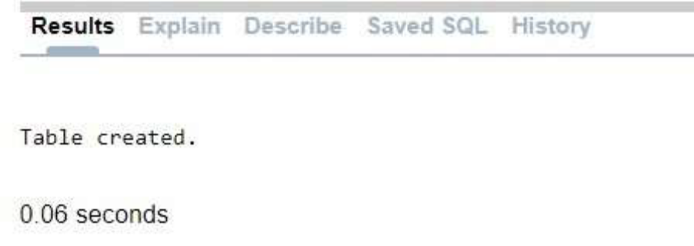

create table location(
location_id int primary key,
street varchar2(20),
city_key references city(city_key)
);

create table wholesaler(
seller_id int primary key,
company varchar2(20),
phone_number varchar2(20)
);

create table datetime(
date_id int primary key,
EntryDate TIMESTAMP
);

create table product(
product_id int primary key,
p_name varchar2(255),
p_price int,
p_type varchar2(20)
);

create table mart(
location_id REFERENCES location(location_id),
seller_id REFERENCES wholesaler(seller_id),
date_id REFERENCES datetime(date_id),
product_id REFERENCES product(product_id),
tot_amount int,
tot_quantity int
);

2. Inserting values in the tables created
insert into wholesaler values(1,'Lalwani Enterprises','1234567890');
insert into wholesaler values(2,'Kursija Enterprises','0987654321');
insert into wholesaler values(3,'Kumar Enterprises','5678901234');
insert into wholesaler values(4,'Your Mart Wholesale','5433167899');
insert into wholesaler values(5,'Proper Wholesale','6789543321');
insert into wholesaler values(6,'High Cost Wholesale','1122334455');
insert into wholesaler values(7,'Wholesale Dealers','6677889900');
insert into wholesaler values(8,'Crafted Clothing','0678951234');
insert into wholesaler values(9,'Lifestyle Wholesale','2134590876');
insert into wholesaler values(10,'Super Star Wholesale','9087651234');
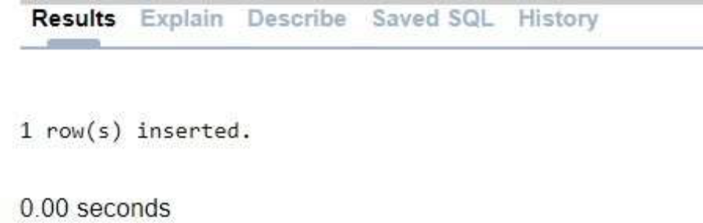

Desc wholesaler;
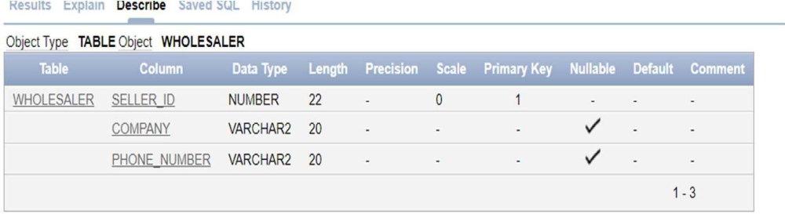

select * from wholesaler;
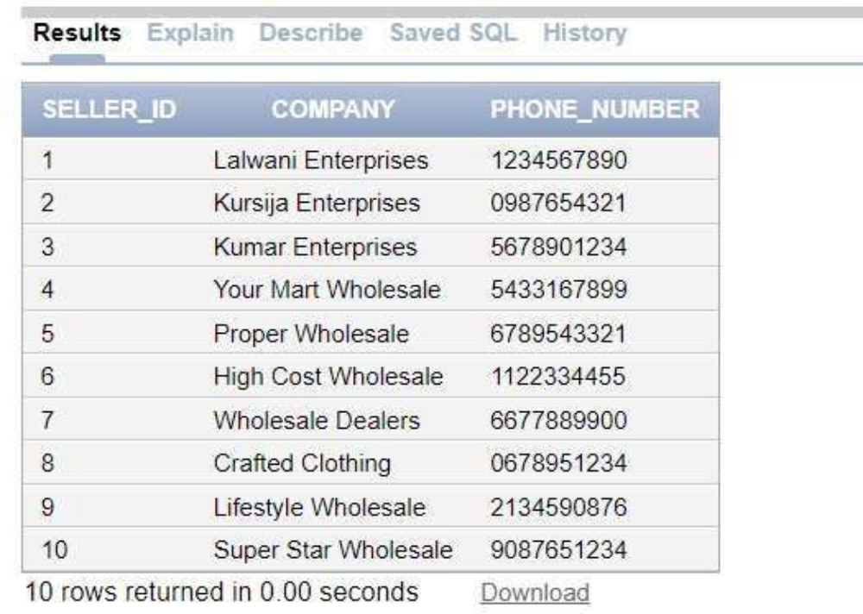

insert into city values(1,'Mumbai','Maharashtra','India');
insert into city values(2,'Ahemdabad','Gujarat','India');
insert into city values(3,'Udaipur','Rajasthan','India');
insert into city values(4,'Jaipur','Rajasthan','India');
insert into city values(5,'Patna','Bihar','India');
insert into city values(6,'Amritsar','Punjab','India');
insert into city values(7,'Pune','Maharashtra','India');
insert into city values(8,'Guwahati','Assam','India');
insert into city values(9,'Kolkata','West Bengal','India');
insert into city values(10,'Agra','Uttar Pradesh','India');

Desc city;
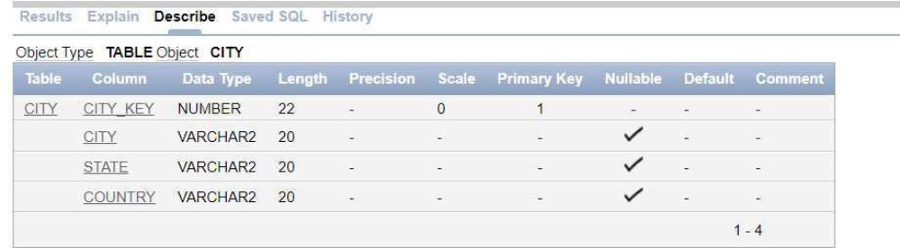

select * from city;
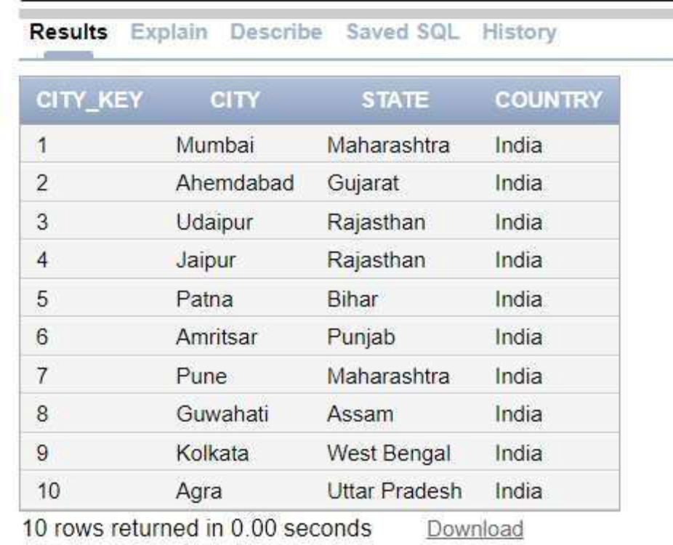

insert into location values(1,'Peddar Road',1);
insert into location values(2,'Carter Road',1);
insert into location values(3,'Manek Chowk',2);
insert into location values(4,'IIM Road',2);
insert into location values(5,'City Palace Road',3);
insert into location values(6,'Rani Road',3);
insert into location values(7,'Hawa Mahal Road',4);
insert into location values(8,'JLN Marg',4);
insert into location values(9,'Exhibition Road',5);
insert into location values(10,'Patna City',5);
insert into location values(11,'Hall Bazaar',6);
insert into location values(12,'Mall Road',6);
insert into location values(13,'MG Road',7);
insert into location values(14,'Kalyani Nagar',7);
insert into location values(15,'G.S. Road',8);
insert into location values(16,'A.T. Road',8);
insert into location values(17,'Park Street',9);
insert into location values(18,'Lake Road',9);
insert into location values(19,'Agra Fort Area',10);
insert into location values(20,'M.G. Road',10);

Desc location;
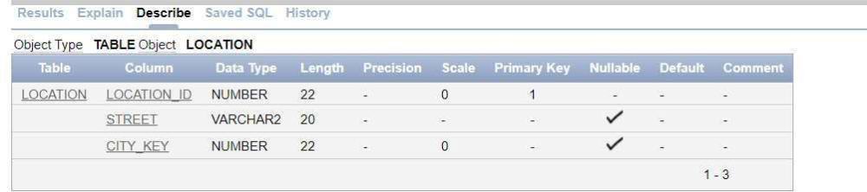

select * from location;
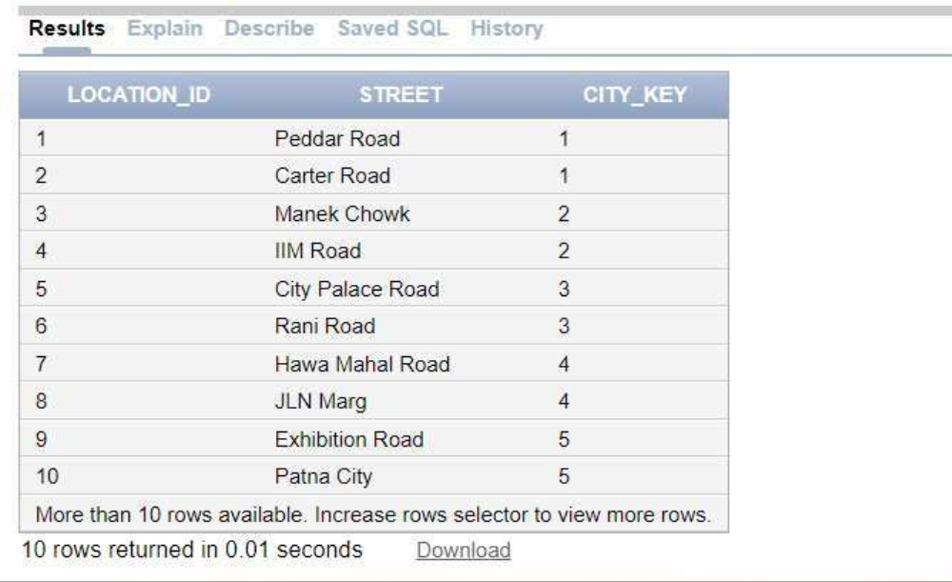

insert into datetime values(1, TO_TIMESTAMP('2023-09-24 08:30:00', 'YYYY-MM-DD
HH24:MI:SS'));
insert into datetime values(2, TO_TIMESTAMP('2023-07-14 18:30:00', 'YYYY-MM-DD
HH24:MI:SS'));
insert into datetime values(3, TO_TIMESTAMP('2022-12-31 09:30:00', 'YYYY-MM-DD
HH24:MI:SS'));
insert into datetime values(4, TO_TIMESTAMP('2022-10-06 09:00:00', 'YYYY-MM-DD
HH24:MI:SS'));
insert into datetime values(5, TO_TIMESTAMP('2023-09-24 11:11:00', 'YYYY-MM-DD
HH24:MI:SS'));
insert into datetime values(6, TO_TIMESTAMP('2022-12-15 10:30:00', 'YYYY-MM-DD
HH24:MI:SS'));
insert into datetime values(7, TO_TIMESTAMP('2023-08-12 16:45:00', 'YYYY-MM-DD
HH24:MI:SS'));
insert into datetime values(8, TO_TIMESTAMP('2022-10-14 19:23:00', 'YYYY-MM-DD
HH24:MI:SS'));
insert into datetime values(9, TO_TIMESTAMP('2023-01-01 22:48:00', 'YYYY-MM-DD
HH24:MI:SS'));
insert into datetime values(10, TO_TIMESTAMP('2023-04-16 17:56:00', 'YYYY-MM-DD
HH24:MI:SS'));

Desc datetime;
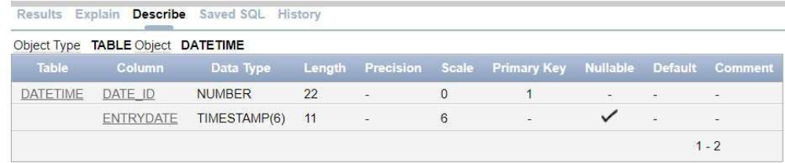

select * from datetime;
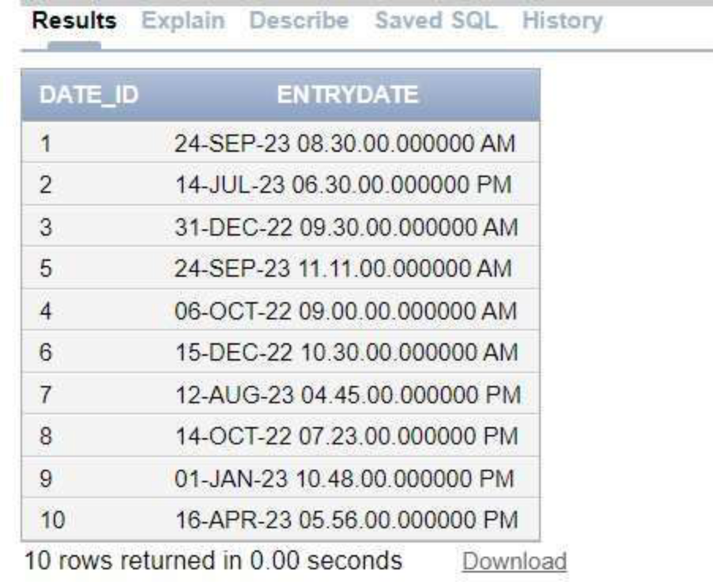

insert into product values(1,'Notebooks',200,'Educational Material');
insert into product values(2,'Bags',250,'Backpacks');
insert into product values(3,'Kitechenware',500,'Household Material');
insert into product values(4,'Shoes',800,'Footwear');
insert into product values(5,'Sandals',400,'Footwear');
insert into product values(6,'Television',900,'Household Material');
insert into product values(7,'Mobile',10200,'Electronic Gadgets');
insert into product values(8,'Dinner set',1500,'Kitchen');
insert into product values(9,'Camera Bag',600,'Backpacks');
insert into product values(10,'Dry Snacks',200,'Grocery');

Desc product;
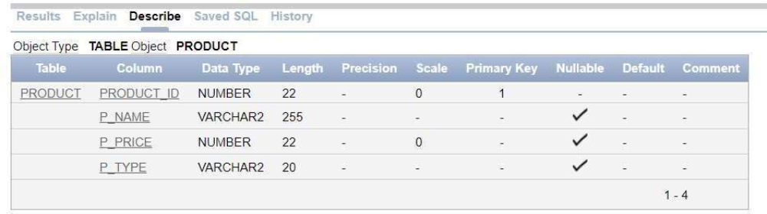

select * from product;
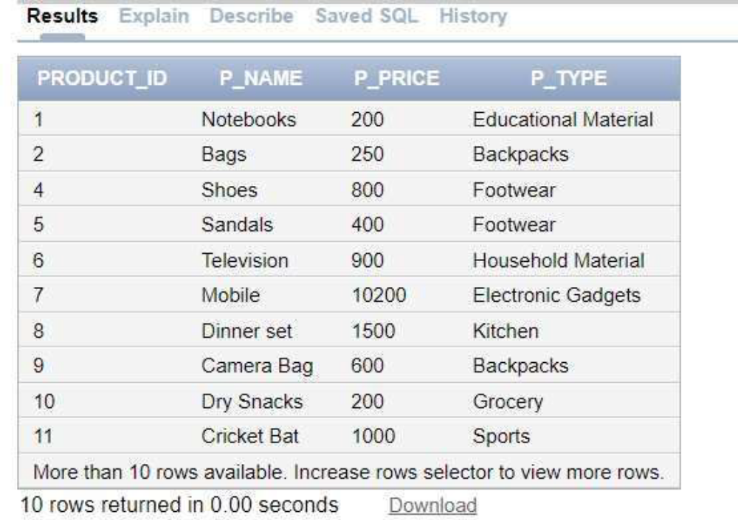

insert into mart values(1,1,1,1,1000,5);
insert into mart values(2,2,2,2,1500,6);
insert into mart values(3,3,3,3,2000,4);
insert into mart values(4,4,4,4,2400,3);
insert into mart values(5,5,5,5,2000,5);
insert into mart values(6,6,6,6,6300,7);
insert into mart values(7,7,7,7,30600,3);
insert into mart values(8,8,8,8,10500,7);
insert into mart values(9,9,9,9,1800,3);
insert into mart values(10,10,10,10,3000,15);
insert into mart values(1,2,1,1,1200,6);
insert into mart values(2,3,10,3,1000,5);
insert into mart values(3,4,9,1,5000,5);

Desc mart;
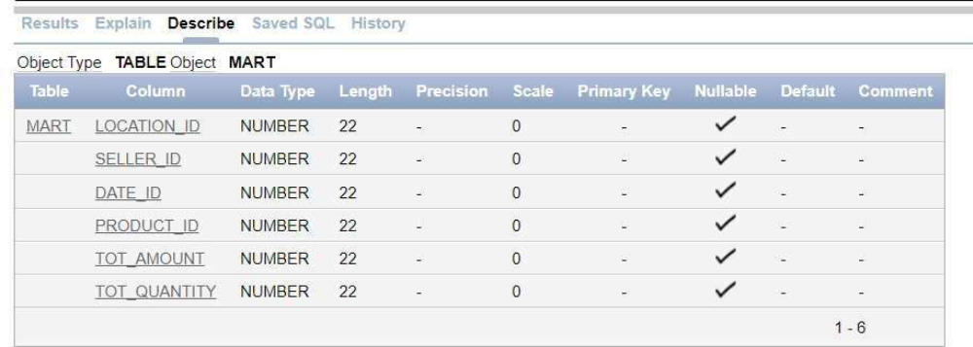

select * from mart;
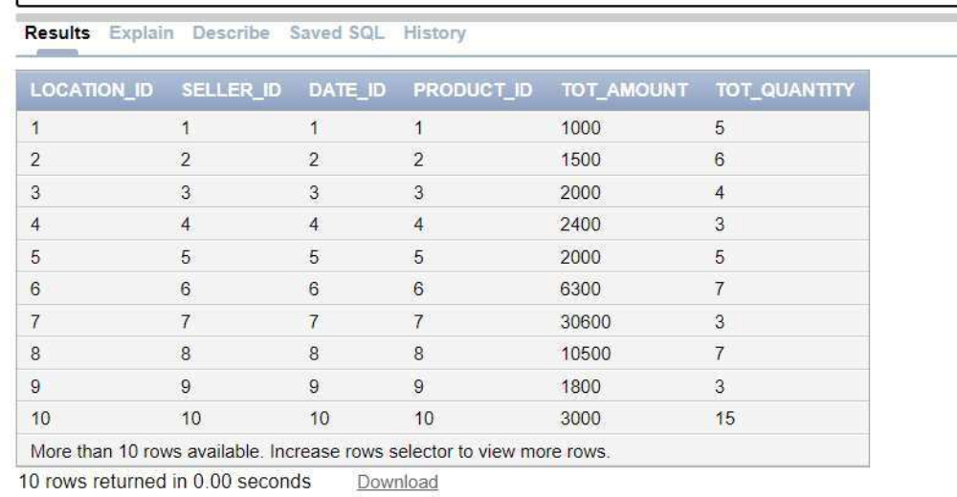

Conclusion: Thus, in this experiment, we have implemented all the dimension tables and fact table based on experimental case study which is “Restaurant Management System”.

